Understanding pre-WWI diplomatic relations through political cartoons
Difficulty
2

Name︰_______________ （ ） Class︰__________

Historical skill | Interpretating political cartoons
Related Textbook Content | 3A pp. 4-7, 13

Study the source below and answer the following questions.

Source A A cartoon published in Britain in 1909, entitled ‘No Limit’.
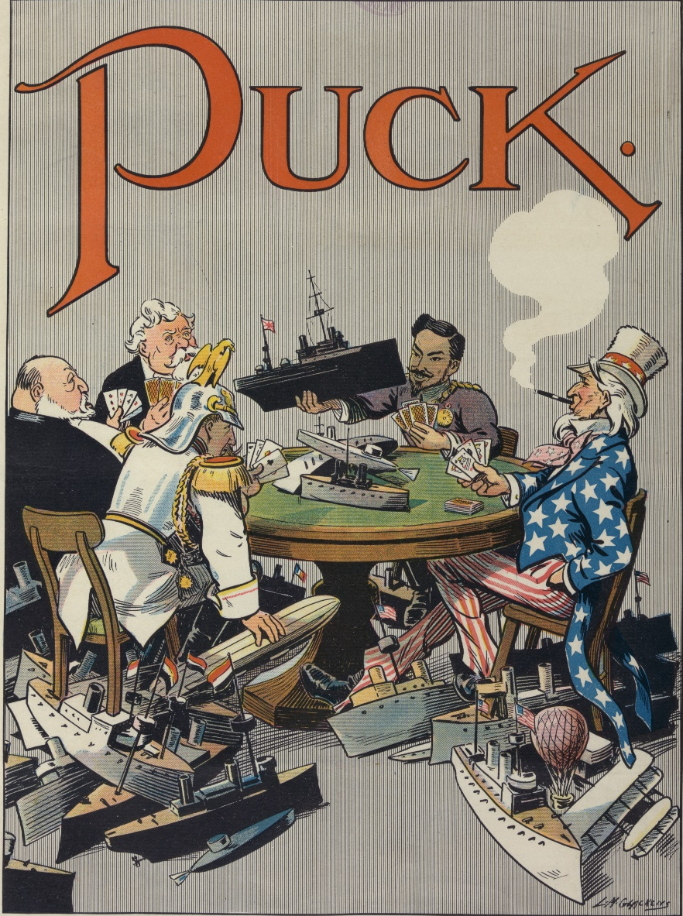
Y
X
Z
1) With reference to Source A, complete the following content.
- Publishing year: _____________
- Publishing country: _____________
- Cartoon title: ________________

2) Which countries were represented as X, Y and Z respectively? Cite one clue from the source to support each of your answers.

 | Country | Clue
X
Y
Z

3) According to Source A, infer the relationship between countries before the First World War.
As reflected in Source A, countries were taking part in a cards game, they put _____________________________________ on the table as staks and kept increasing the stakes. This symbolised that countries were carrying a fierce ________________, reflecting their [ friendly / tense ] relationship.
Answers

1)
- Publishing year: ___1909____
- Publishing country: ____Britain____
- Cartoon title: ____‘No Limit’______

2)
 | Country | Clue
X | Germany | A German symbol, the Imperial Eagle, on his helmet. / There is a German flag on his warship. (Choose one answer)
Y | Japan | He is the Meiji Emperor of Japan. / He has an Asian facial appearance. / There is a Japanese flag on his warship. (Choose one answer)
Z | The US | He is Uncle Sam, the symbol of the United States. / The clothes he wears are decorated with the Stars and Stripes, patterns of the American flag. / There is an American flag on his warship. (Choose one answer)

3. As reflected in Source A, countries were taking part in a cards game, they put _________dreadnoughts and submarines________ on the table as staks and kept increasing the stakes. This symbolised that countries were carrying a fierce _____arms race____, reflecting their [ friendly / tense ] relationship.

